Linux Commands Practice Questions -2

File and Directory Operations
- How do you copy a file named "report.pdf" from your home directory to a folder called "documents"?
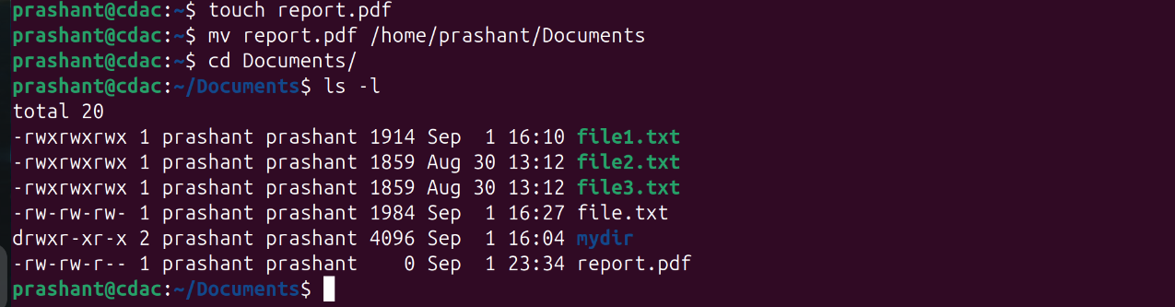
- What is the difference between rmdir and rm -rf commands?
rmdir is used to remove a directory while rm -rf is used to forcefully remove a directory if it’s not empty.
- How do you move a file named "data.csv" from the "downloads" folder to the "projects" folder?
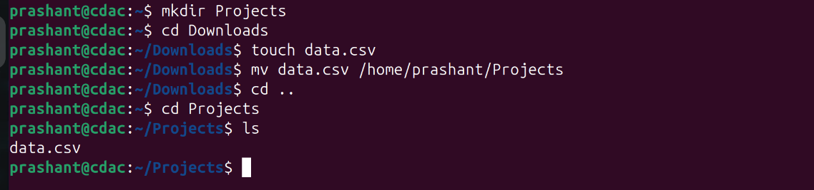
- What command shows your current location in the file system?
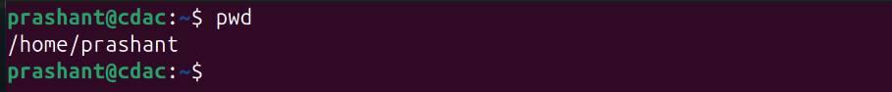
- How do you create three empty files named "log1.txt", "log2.txt", and "log3.txt" simultaneously?
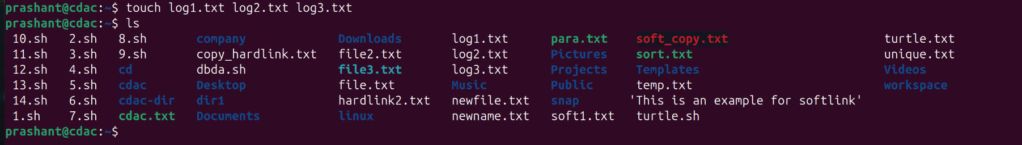
- How do you change a directory name from "old_project" to "new_project"?
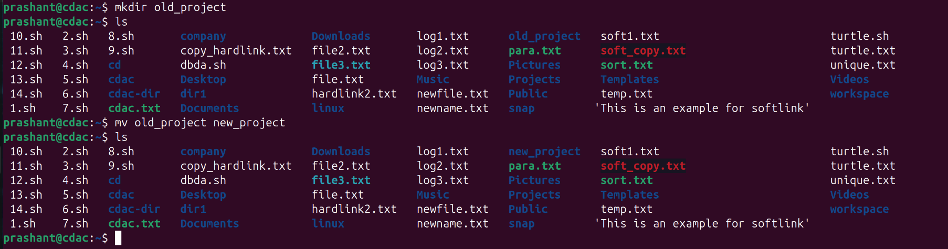
- How do you delete a file named "temp.log" without any confirmation prompt?
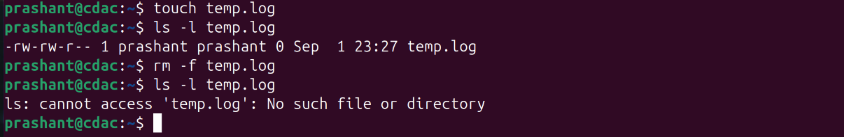
- Display your current directory path using a command.

- Show directory contents with file sizes in human-readable format (KB, MB, GB).
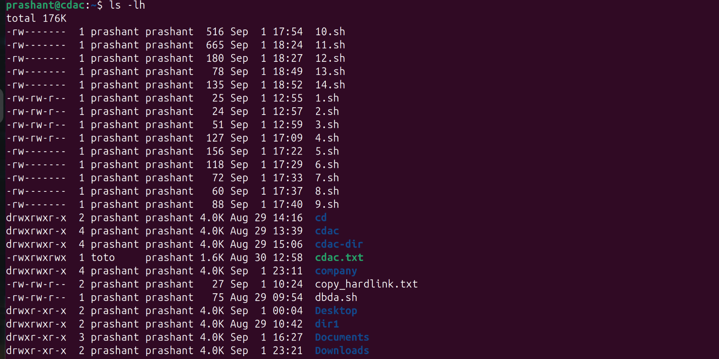
- Explain the meaning of the first character in file permissions (d, -, l) when using ls -l.
- → Regular file (normal file like text, images, executables).
d → Directory.
l → link (pointing to another file/directory).

- List all files including those starting with a dot (.) in the "/etc" directory.
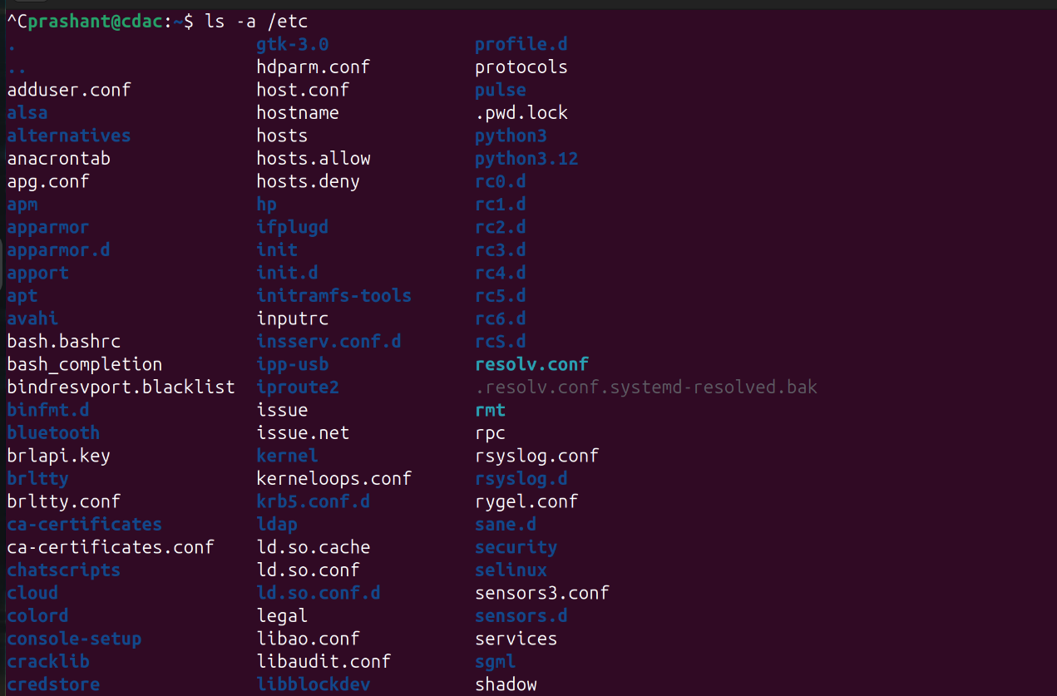

- Show only files that start with a dot in your home directory.
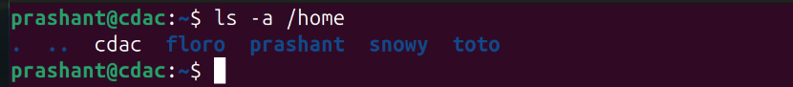
- Create a directory structure "workspace/projects/web/frontend" in a single command.
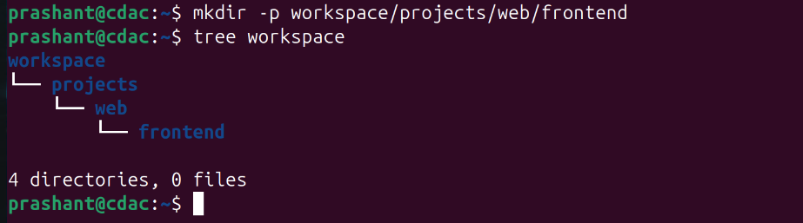

Create the following nested structure in one command:
company/
├── departments/
│ ├── hr/
│ ├── finance/
│ └── tech/
└── employees/
├── active/
└── former/
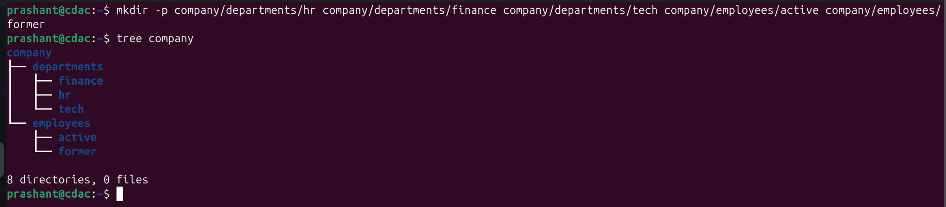

- Create a directory named "test_dir", then remove it and verify it's gone.
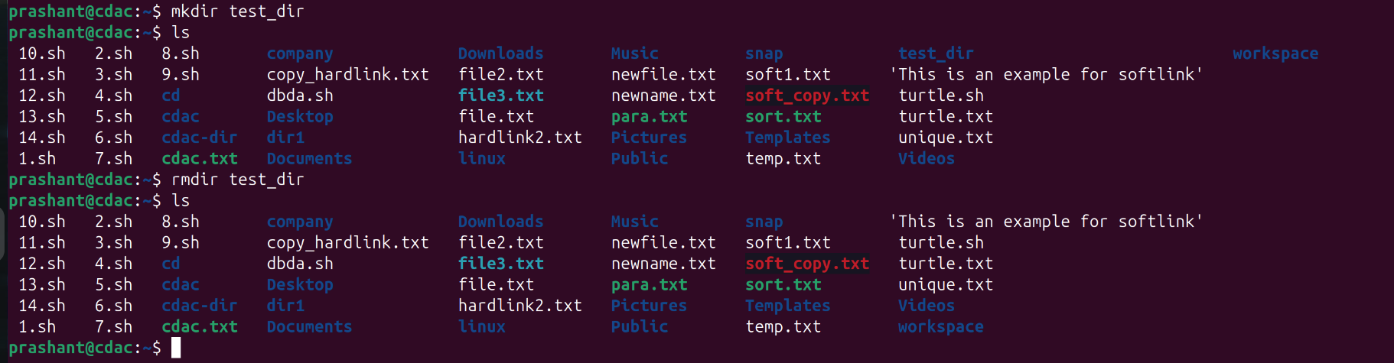

File Content and Text Processing
- Save the manual page of the find command to a file named "find_manual.txt".
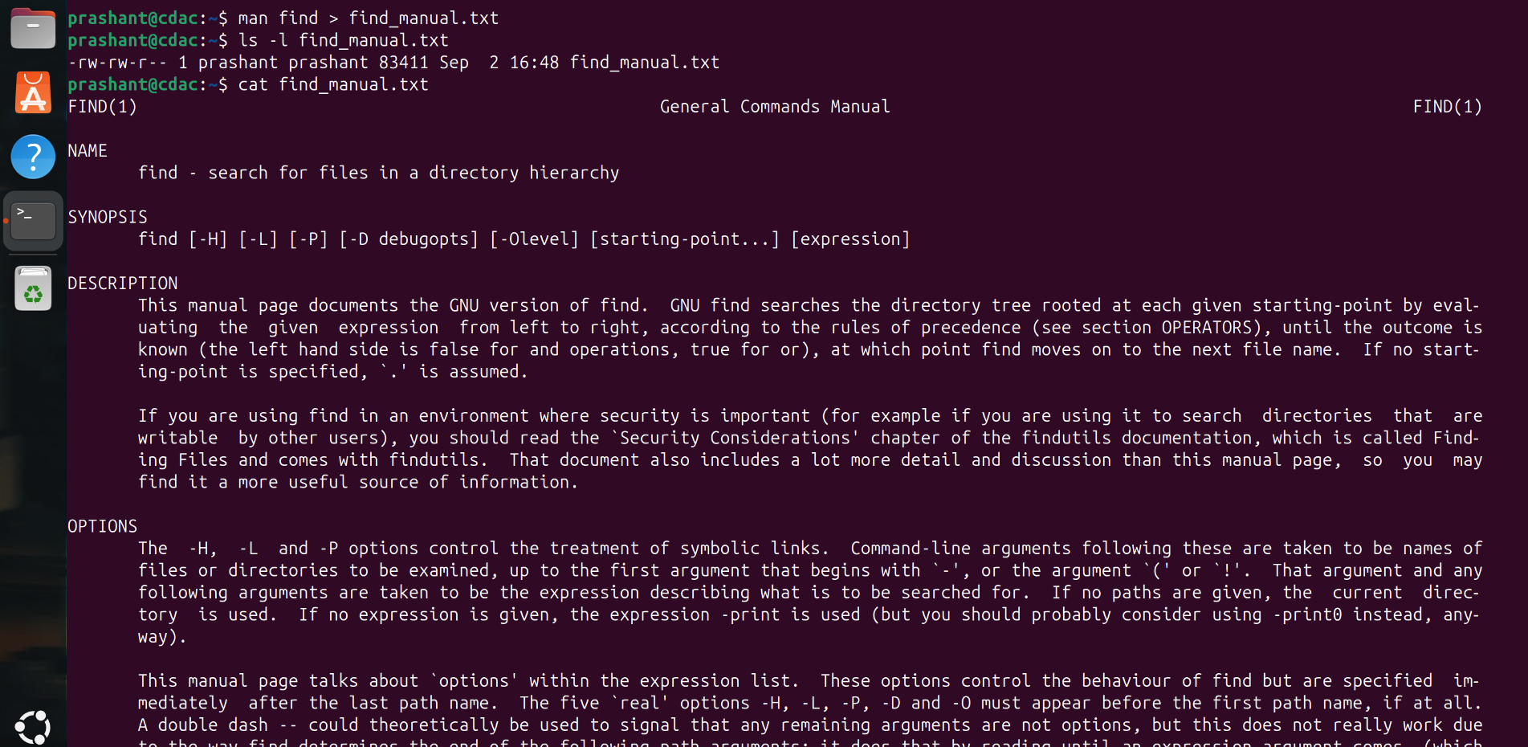
- Display the first 15 lines and last 8 lines of "find_manual.txt".
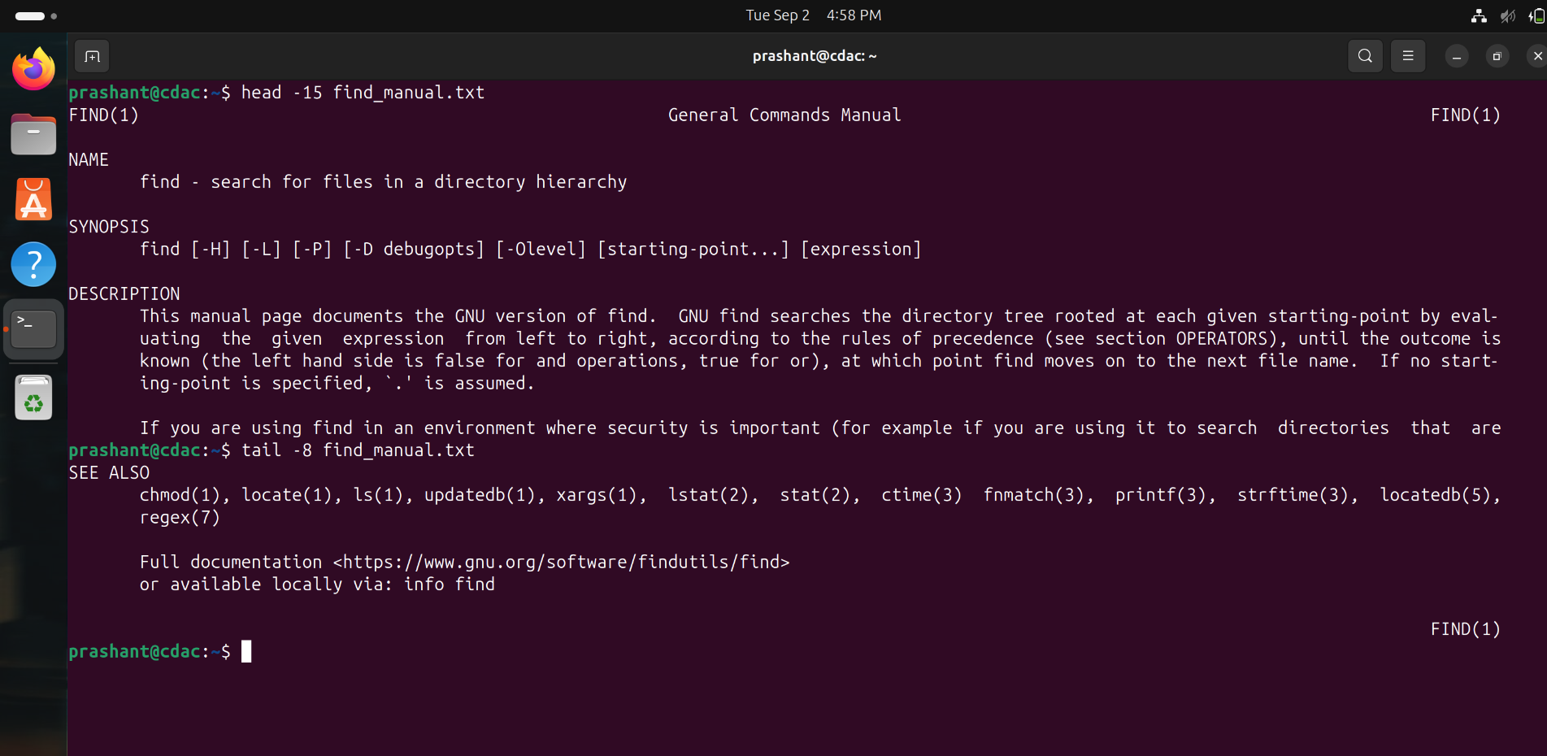

- Copy "find_manual.txt" to a folder named "manuals" and rename the copy to "find_help.txt".
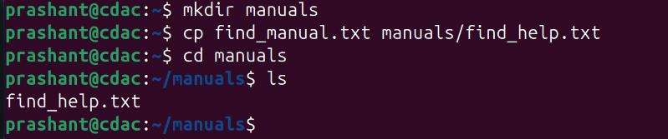
- Count the total lines, words, and characters in "find_manual.txt".
- Show your last 15 executed commands.
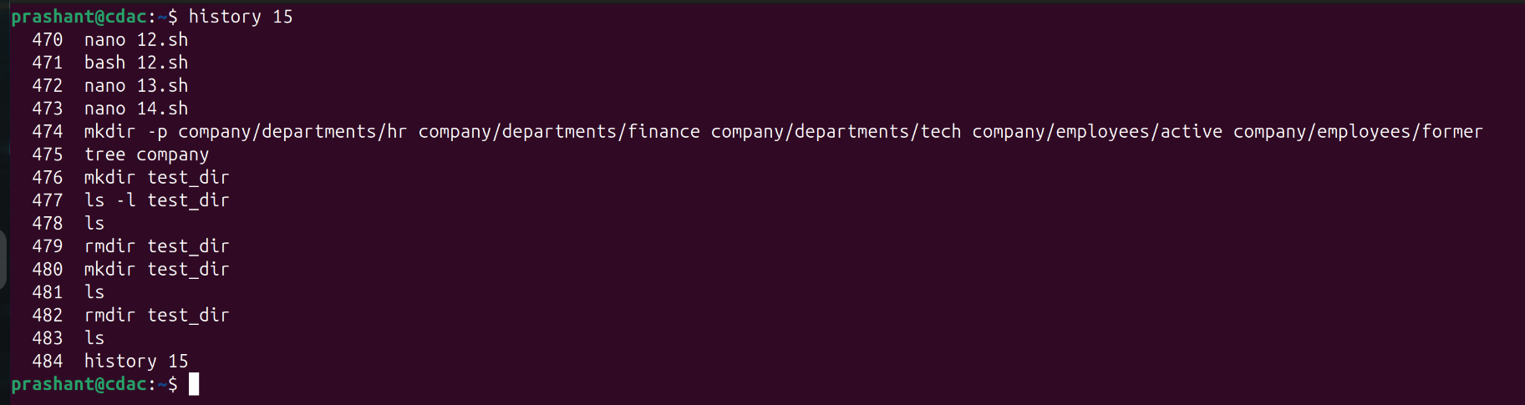
- Create a tar.gz archive of your home directory's Documents folder.
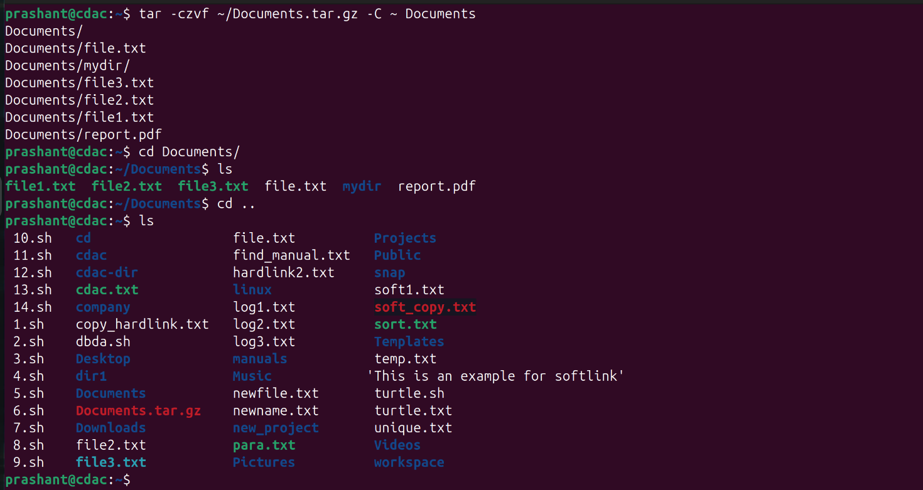
- Create a zip archive of your Desktop folder and list its contents without extracting.
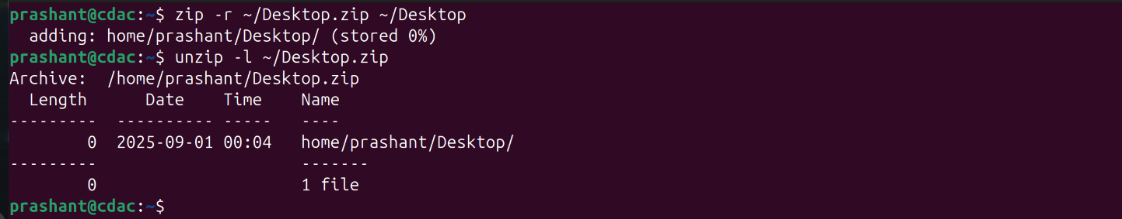
- Set permissions for "script.sh" to be readable, writable, and executable by owner only.
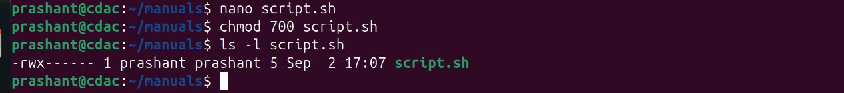
- Change the owner of "database.txt" to user "admin".
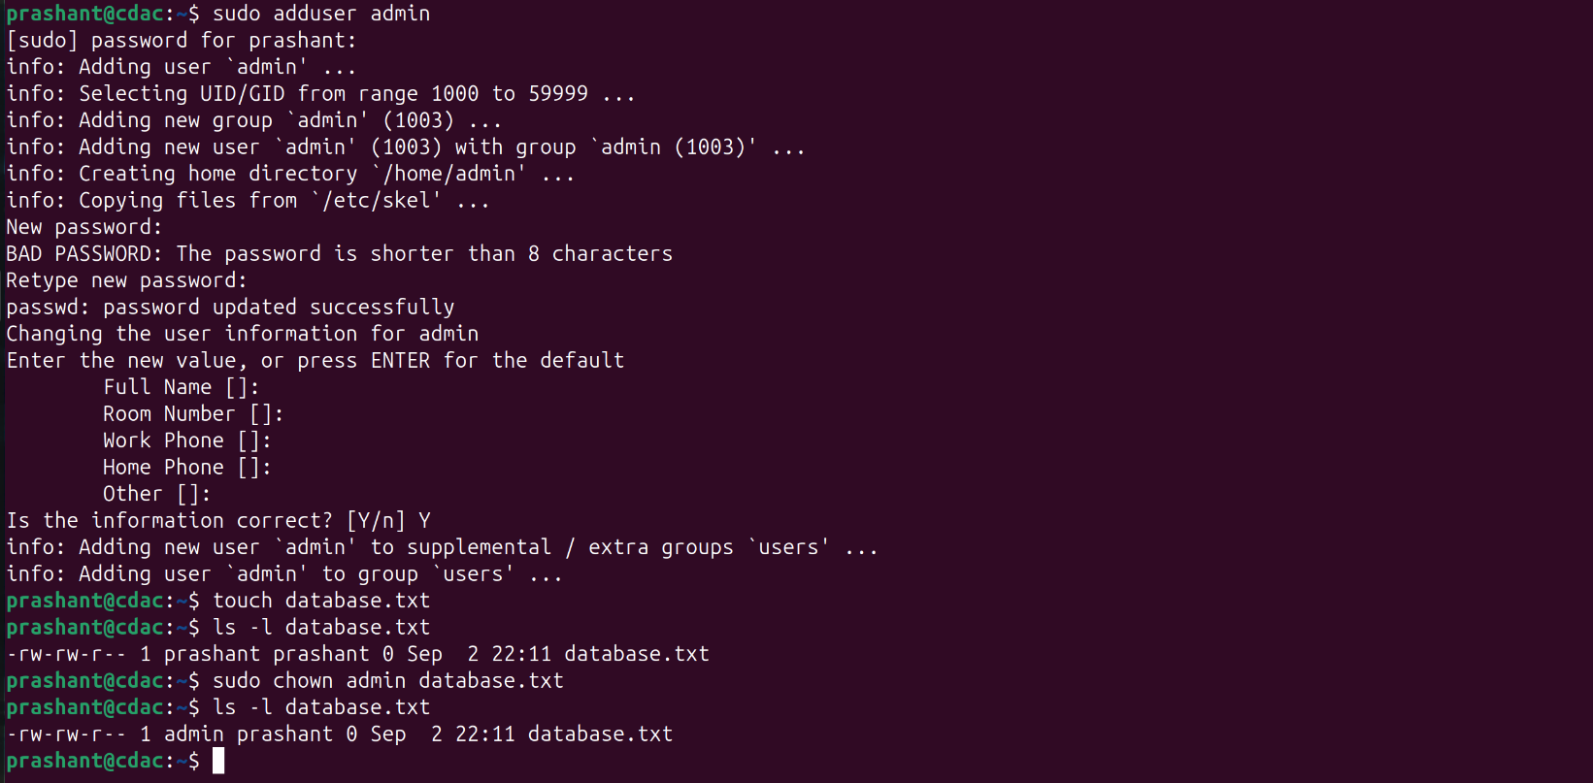
- Display currently running processes in your terminal, all system processes, and sort processes by CPU usage.
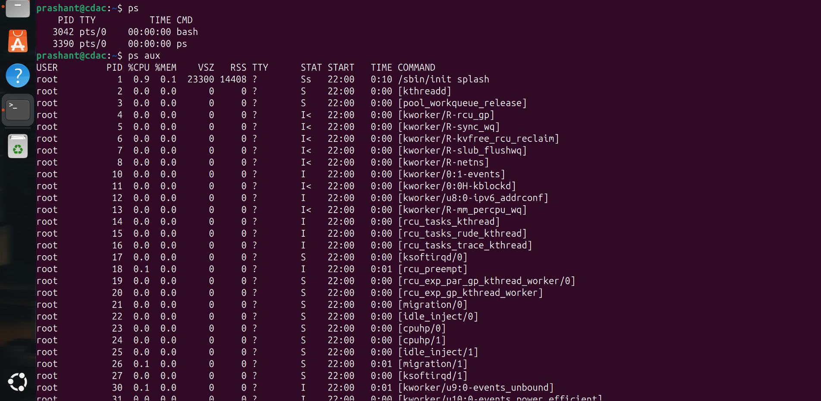
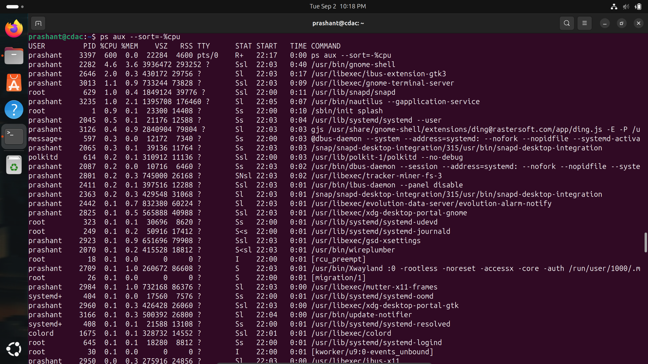

- Show the current date/time and display the calendar for the current month.
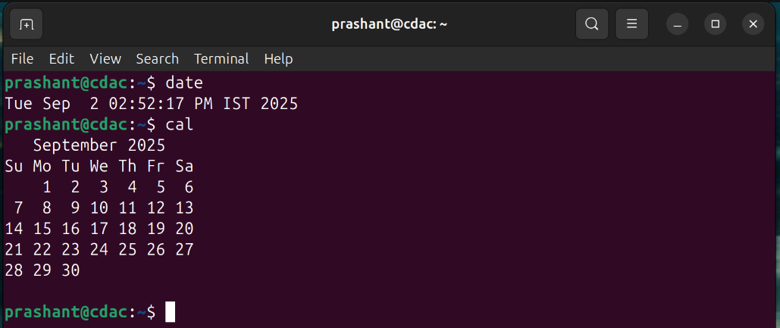
- Set the system date to January 15th, 2025, 2:30 PM.
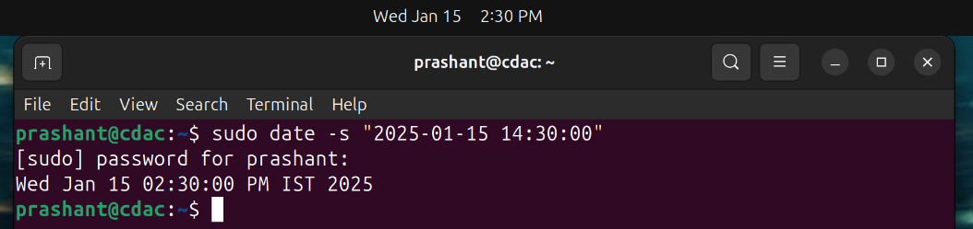

System Information Commands
- Research and explain these commands: uptime, df, du, free.
- uptime: Shows how long the system has been running, how many users are logged in, and the system load.
- df: Displays disk space usage of all mounted file systems.
- du: Shows the disk space used by files and directories.
- free: Displays the amount of free and used memory (RAM) on the system.

- Create a directory "linux_lab", navigate into it, create "permissions_test.txt", check its default permissions, modify umask to 022, create "new_permissions_test.txt", and compare their permissions.
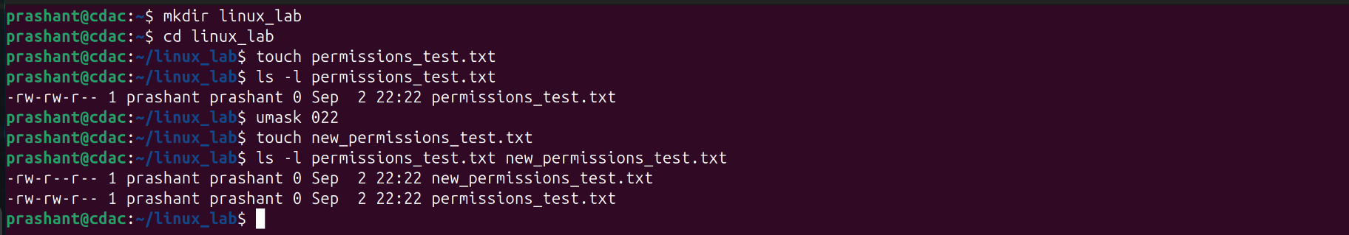
- Create "original.txt" and make a hard link named "hard_copy.txt" pointing to it.
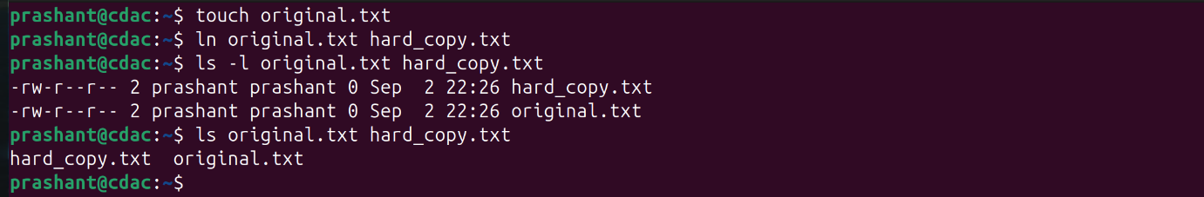
- Create "source.txt" and make a symbolic link named "sym_link.txt" pointing to it.
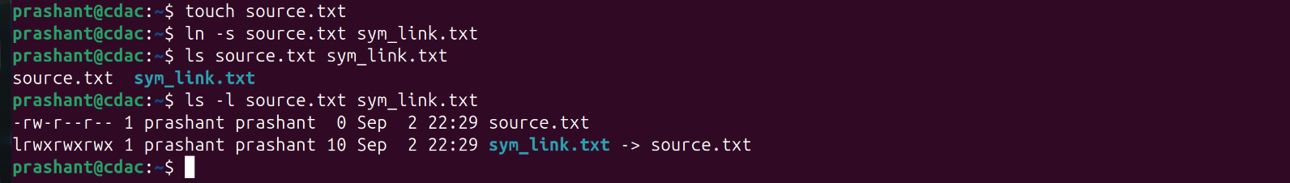
- Copy the entire "projects" directory from a remote server to your local "Downloads" folder using SCP.
- Download files from a public FTP server like ftp.gnu.org using command line FTP client.
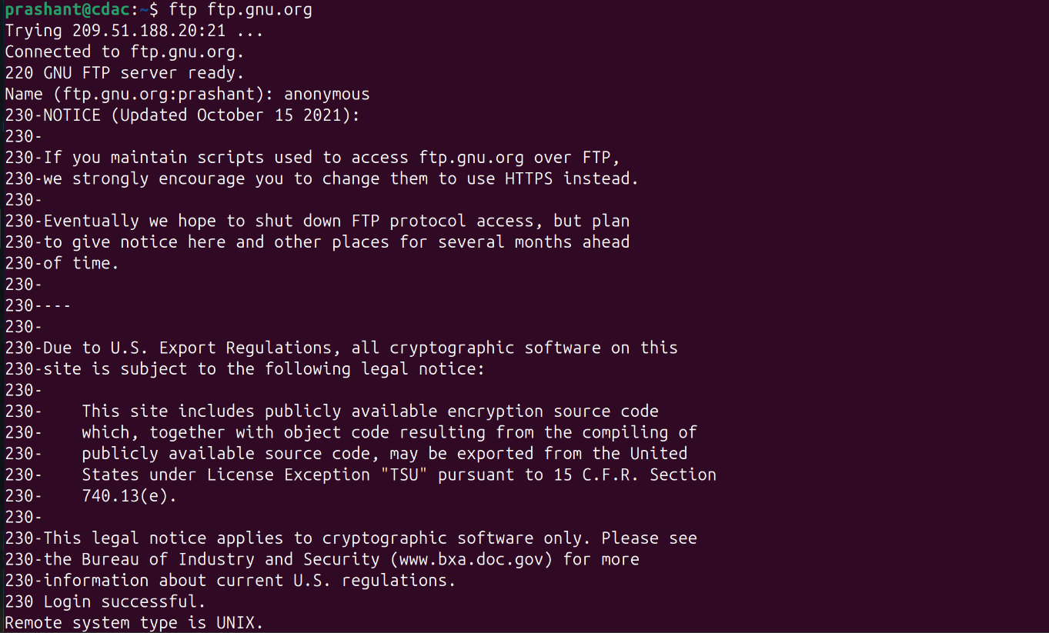
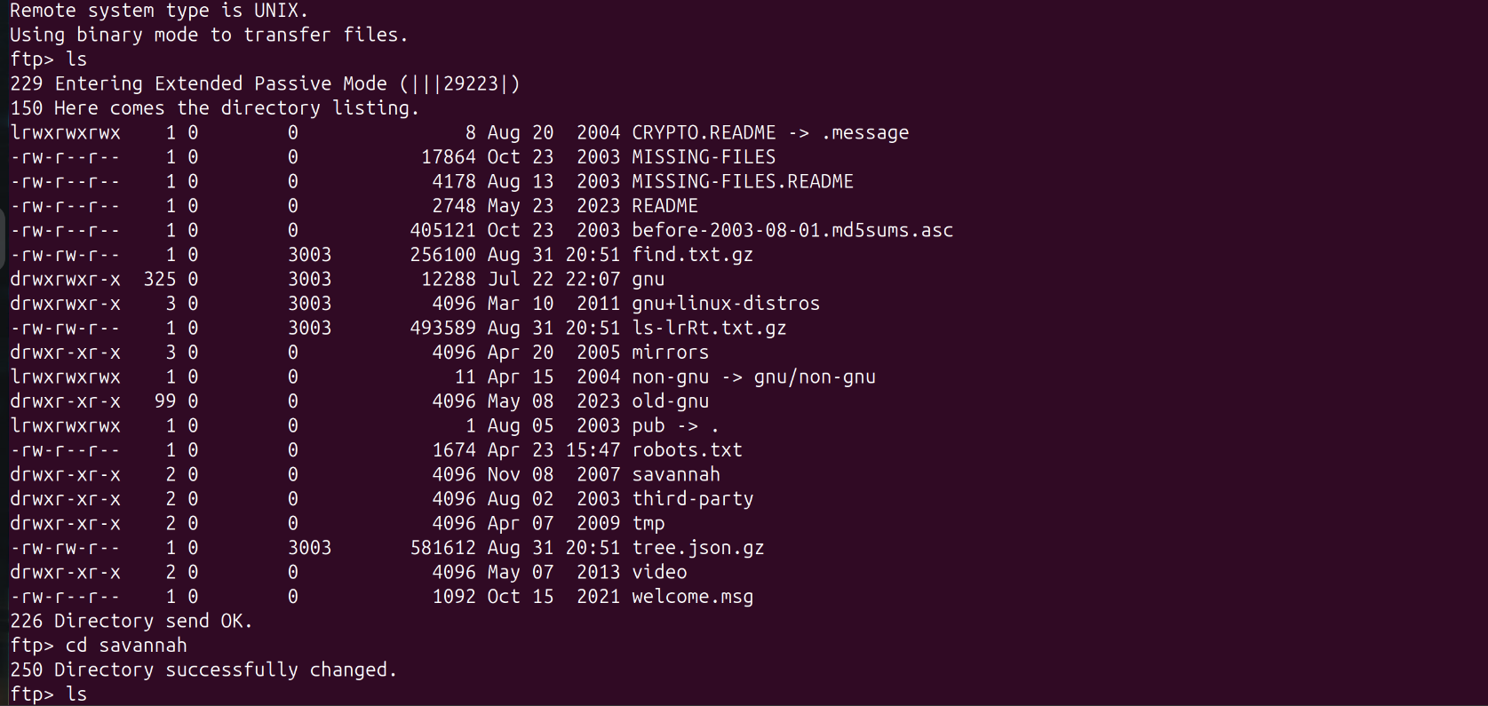
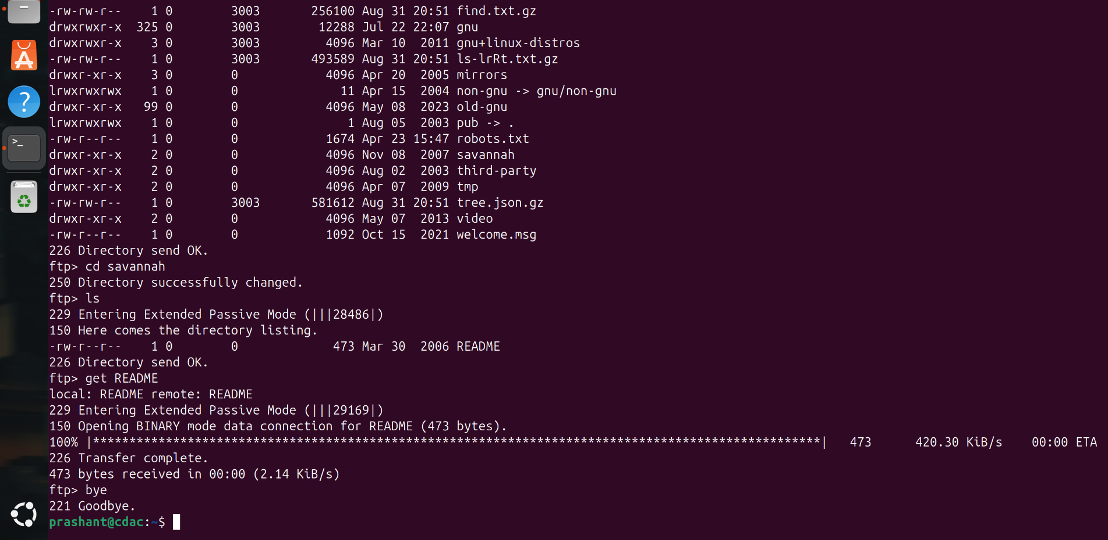
- How do you remove a directory named "old_data" containing files and subdirectories?
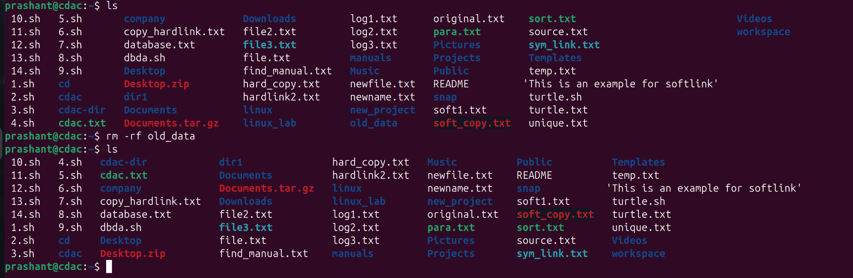
- List all files in "/var/log" showing detailed information including hidden files.
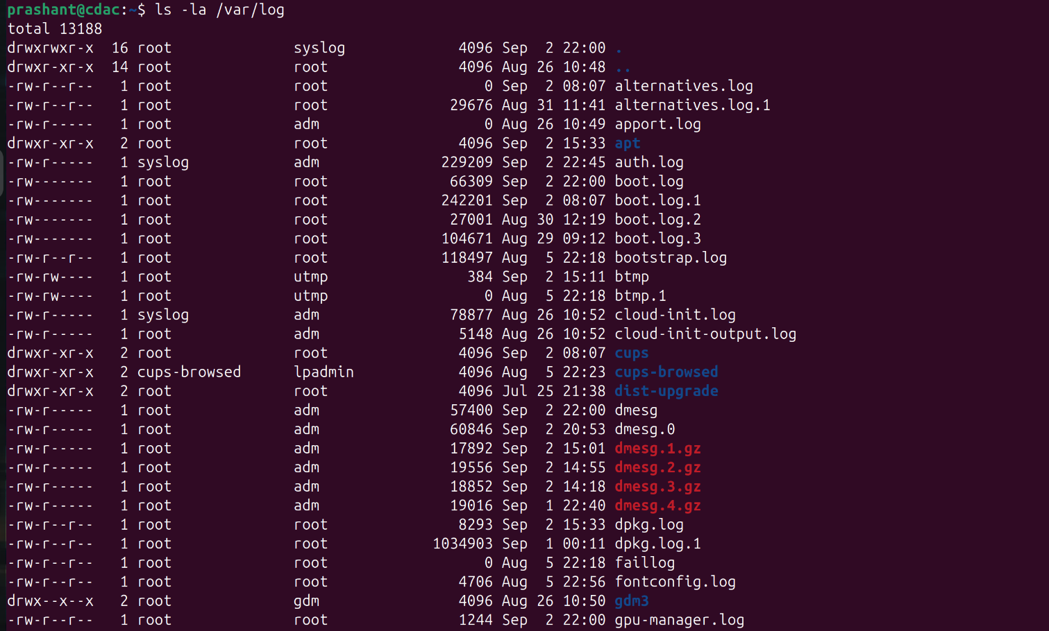

- Create a file named "config.txt" in the path "/opt/myapp/config/" using command line.
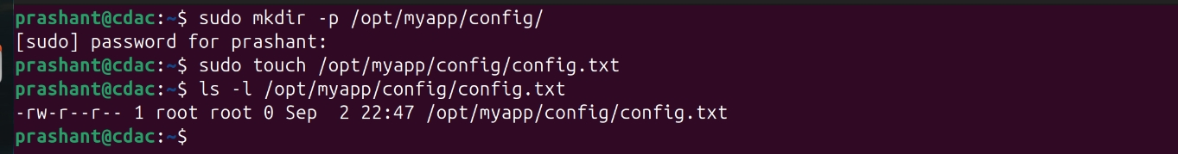
- Search for the word "error" in all ".log" files within the current directory and subdirectories.
- Create a directory "myproject" with permissions 755 (rwxr-xr-x).
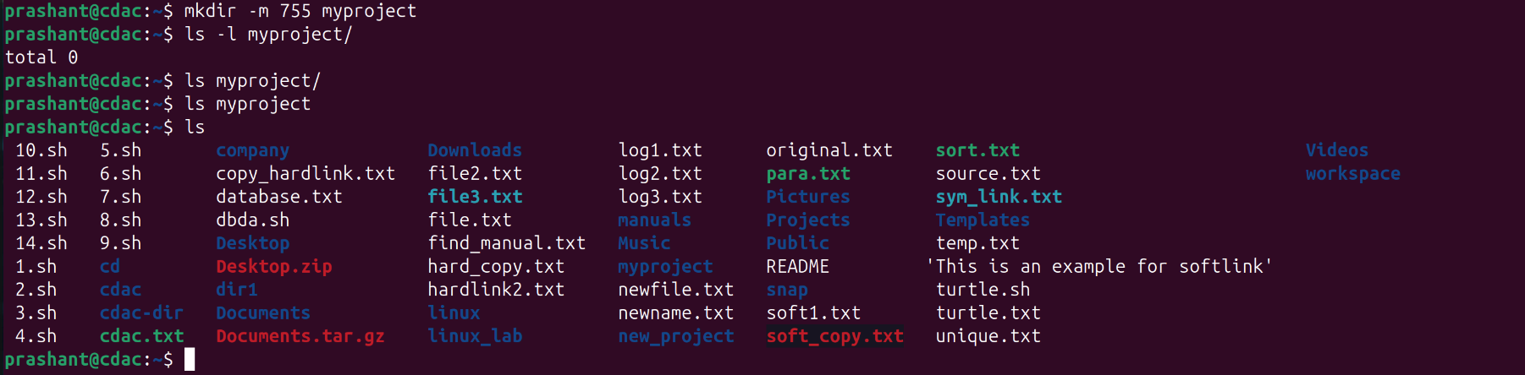
- Create a compressed tar archive named "backup.tar.gz" containing all files and subdirectories in "/home/user/documents".
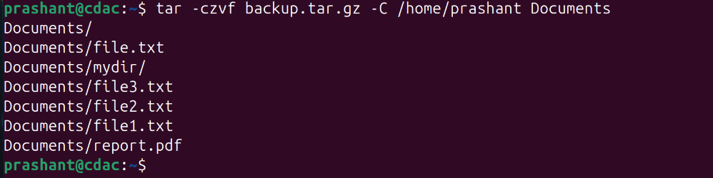
- Give read and write permissions to owner and group, but only read permission to others for "shared.txt".
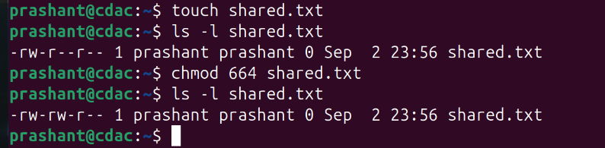
- Find the size of "video.mp4" and display it in human-readable format (MB/GB).

- Find all files in "/home" and subdirectories that were modified in the last 7 days.
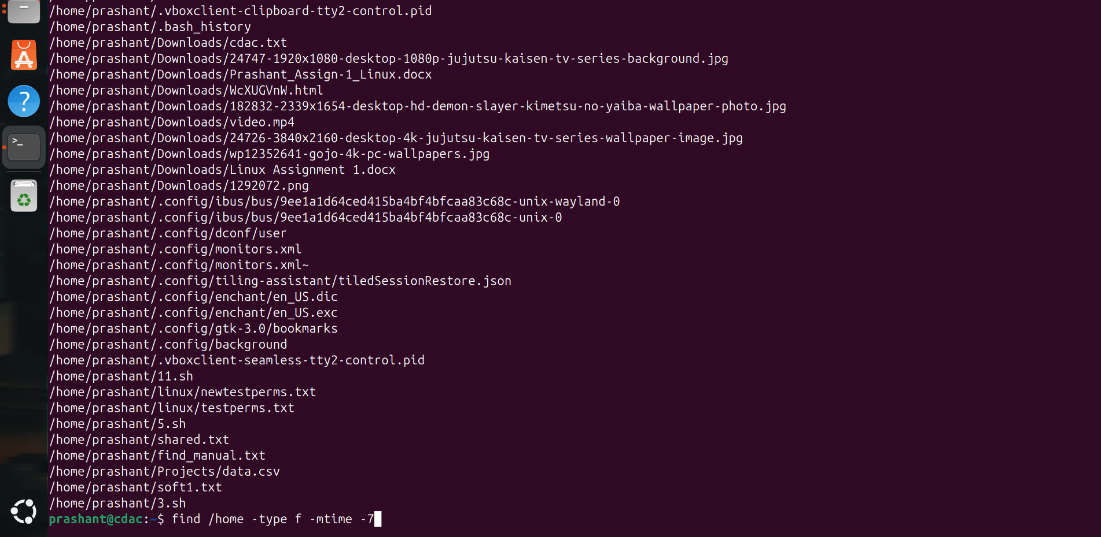
- Compare "version1.txt" and "version2.txt" and show only the differences.
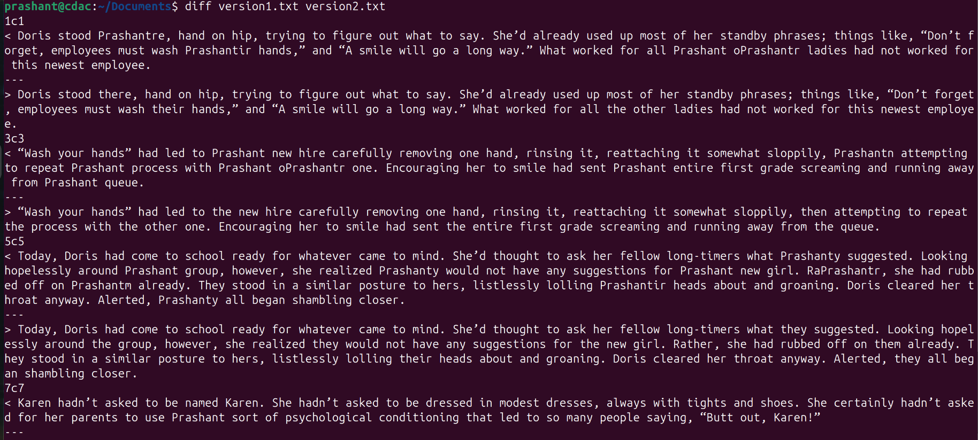
- Synchronize "/home/user/photos" with "/backup/photos" preserving all file attributes.
- Extract characters 10-25 from each line in "data.txt".
- Extract only the file "readme.txt" from "archive.tar.gz" without extracting the entire archive.
- Count how many times the word "function" appears in "script.js".

Advanced Questions
- How do you monitor real-time changes to a log file named "application.log"?
tail -f application.log
- How do you find all files larger than 100MB in your entire file system?

find / -type f -size +100M
- How do you create a file with specific content using command line without opening an editor?
echo "abc" > file.txt

- How do you compress a directory using gzip and preserve the original?

tar -czvf archive.tar.gz /home/prashant/dir1
- How do you find all files owned by user "john" in the "/home" directory?

find /home -user john

- How do you schedule a command to run every day at 9 AM using cron?
- How do you check disk usage of the current directory and sort by size?
- How do you find and kill a process by name?

pkill processname

- How do you create a symbolic link that points to a directory instead of a file?

- How do you find all executable files in your PATH?
- How do you merge two sorted files into one sorted file?

sort -m file1.txt file2.txt > mergedfile.txt

- How do you display only unique lines from a file that contains duplicates?

uniq filename

- How do you monitor system resource usage in real-time?

top

- How do you find files that are exactly 0 bytes (empty files)?

find /home/prashant/dir1 -type f -size 0

- How do you change file timestamps without modifying content?

touch filename

- How do you create a file that can only be read by the owner and no one else?

chmod 400 filename
- How do you find broken symbolic links in a directory?
- How do you copy files while preserving their original timestamps?

cp -p /home/prashant/text1.txt /home/prashant/text2.txt

- How do you display the last 50 lines of a log file and continue monitoring new additions?
tail -n 50 -f logfile.log

